RECRUITMENT SYSTEM

SOFTWARE REQUIREMENT SPECIFICATION

SATHIYAMOORTHY G

1. INTRODUCTION

1.1 Purpose

The recruitment and selection is the major function of the human resource department and recruitment process is the first step towards creating the competitive strength and the recruitment strategic advantage for the organizations.
Recruitment process involves a systematic procedure from sourcing the candidates to arranging and conducting the interviews and requires many resources and time.
1.2 Scope
To structure the recruitment policy of company for different categories of employees.
To analyze the recruitment policy of the organization and to provide a systematic recruitment process.
It extends to the whole organization. It covers corporate office, sites and works appointments.

1.3 Definition
The Recruitment Process is immediately followed by the selection process i.e. the final interviews and the decision making, conveying the decision and appointment formalities.
Recruitment is the process of selecting the most suitable candidate for a specific job requirement.

1.4 References
This web application has been prepared on the basis of discussion with Team members and also taken information from following websites,
- Google.com
- Wikipiedia.org

1.5 Technologies To Be Used

- JSP: Application Architecture.
- DB2: Database
- HTML: Hyper Text Markup Language.

1.6 Overview
This SRS document contains many use case diagram and description about all use case diagrams have been included in this document. It also gives the functional and non functional requirement.

2. OVERALL DESCRIPTION

The following description gives the general factors that affect system and its requirements.
- Candidate should finish his/her degree and should have proper certificate while applying for job and the candidate should satisfy the eligibility criteria.
- The resume should be in the form what that company specified while advertising.
- The HR has the full permission to select or reject the candidate for interview.
- If the candidate is selected for the particular job means all details about the candidate will be added to the company database and the modification can also be done.

2.1 Project Perspectives

- HR and Candidate plays a major role in the recruitment process.
- The necessary details of the candidate have to be submitted to the HR.
- Verification has been done by the HR.
- Selected candidate should be call to Interview.
- HR intimates the selected candidate.
- Finally Candidates accept or reject his offer letter.

2.2 Use-Case Model Survey

The use case diagrams contains two actor HR , Candidates and five use case Notify the Vacancy ,fill referral form, Selection of Eligible Candidates, Interview Process, Intimation of Selected Candidate s Respectively.

Actors Documentation:

1. HR Head:
HR Head is an actor who informs about the vacancy to candidates and also matches the skills of the referred candidates with their kills, required for the vacant position and shortlist them. HR Head is also responsible for Interview Scheduling.

2. Candiadte:
Candidate is an actor who is referred by HR and applies for the vacancy. If the candidate gets selected them they informs the HR Head about the acceptance or rejection of the offer letter.

Use Cases:

- Notify Vacancy:
In this use-case the HR notify the vacancy details for the required job. If required job. If any vacancy available means the appropriate notification need to be done.

- Fill Referral form:
Application form for the job will be filled by candidate in addition to the application form the resume for the candidate also need to submit. Many candidates will apply for the post from those lists of candidate HR will do the short listing process according to their requirement of the post.

3. Interview Process:
Eligible candidate will be called for the interview process in interview process three steps will be carried out that is Aptitude, Group Discussion (GD) and Interview.
4. Status:
After the interview process, HR list the selected candidates and gives offer letter to him/her. The candidate accepts or rejects the offer letter to fill the vacancy.

2.3 Use Case Diagram
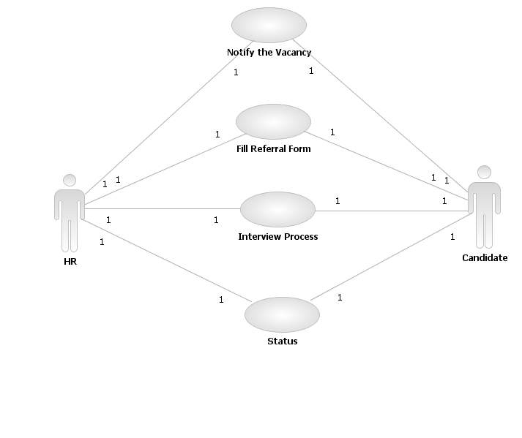

2.4 Assumptions and Dependencies

- The project is done on the basis of selection of candidates for the company
- Every user should be comfortable working with computer and net browsing.
- He should be aware of the Recruitment System.
- User must have comfortable knowledge of English language.

3. REQUIRMENTS
This section describes in detail all the functional and non-functional requirements.
3.1 Use-Case Specifications
1. Notify Vacancy
The HR head of a particular region shall inform details about the vacancy to candidates.
Pre-Condition: Vacancy must exist.
Post-Condition: Details about the vacancy are informed.
2. Fill Referral Form
Online forms are filled by the Candidate .HR head process the filled forms .HR heads selects the list of eligible candidates.
Pre-Condition: Online form must exist. (All the mandatory fields should be filled by the candidate)
Post-Condition: Forms filled are stored in a Information System for processing. The filled forms are sent to the HR. The HR head produces the list of eligible candidates.
3. Interview Process
The Interviews are conducted by the HR head of the region that has the vacancy. The list of selected candidates is obtained after the interview process.
Pre-condition: Study the job description carefully and make sure your application and/or resume compliments what the company is looking for. Plan what to wear to your interview.
Post-Condition: if you get the job, go celebrate! Immediately send thank-you letter. Negotiate your salary when you are offered the job. If you didn’t despair, just start again.
- Status
Candidate is informed about selection the job. Candidate accepts the job offer to fill the vacancy. Or Candidate rejects the offer letter. Candidate application is rejected.
Pre-Condition: Candidate is selected for the job.
Post-Condition: Candidate accepts or rejects the offer.

3.2User Characteristics

The Users are the candidates who should complete his/her degree with percentage above 80).

3.3 Usability
- The system shall allow the users to access the system form the internet using HTML or its derivative technologies. The system uses a web browser as an interface.
- Since all users are familiar with the general usage of browser, no specific training is required.
- The system is user friendly and self-explanatory.

3.4 Reliability

The system has to be very reliable due to the importance of data and damages incorrect or incomplete data can do.

Availability

The system is available 100% for the user and is used 24 hours a day and 365 days a year.
The system shall be operational 24 hours a day and 7 days a week.

Mean Time between Failures (MTBF)

The system will be developed in such a way that it may fail once in a year.

Mean Time to Repair (MTTR)

Even if the system is fails, the system will be recovered back up within an hour or less.

Accuracy

The accuracy of the system is limited by the accuracy of the speed at which the employee of the library and users of the library use of the system.

Access Reliability

The system shall provide 100% access reliability.
  - Performance

Response Time

The splash page or information page should be able to be downloaded within a minute using a 56k modem. The information is refreshed every two minutes. The system shall respond to the member in not less than two seconds from the time of the request submittal. The system shall be allowed to take more time when doing large processing jobs.
Throughput

The number of transactions is directly dependent on the number of users.

Capacity

The system is capable of handling 250 users a time.

  - Supportability

The system designers shall take in to considerations the following supportability and technical limitations.
- Internet Protocols

The system shall be comply with the TCP/IP protocol standards and shall designed accordingly.

- Maintenance

The maintenance of the system shall be done as per the maintenance contract.

- Standards

The coding standards and naming conventions will be as per the American standards.

  - Design Constraints

- The user should have sufficient knowledge of computers.
- The users must know the English language, as the user interface will be
- Provided in English.

3.8 Interfaces

3.8.1 User Interfaces

Our system will make use of the existing web browser such as Microsoft internet explorer or Mozilla.

3.8.2 Hardware Interfaces
- Operating system: windows 9x or above, MAC or UNIX.
- Pentium 2.0 GHz or higher
- RAM: 256 Mb or more
- Hard drive: 10 GB or more
3.8.3 Software Interfaces
Client on internet: Web Browser, Operating System (any)
Web Server: WAS, Operating System (any)

Data Base Server: DB2, Operating System (any)

3.8.4 Communication Interfaces

The Recruitment System will be connected to the World Wide Web.

3.9Licensing Requirements

The usage is restricted to the person who is purchasing the Recruitment System and signs the maintenance contract.

3.10 Legal, Copyright and Other Notices

Recruitment system is a trademark of KCG College of technology and cannot be used without its consent.

Activity Diagram

- Notify Vacancy

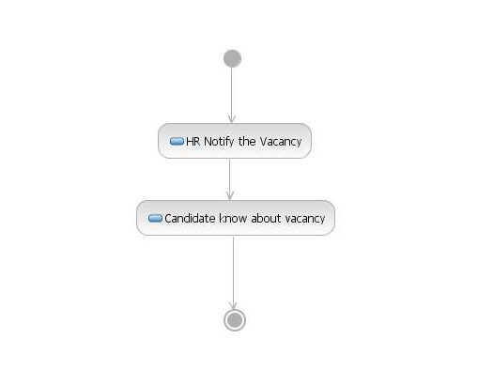
- Fill Referral Form

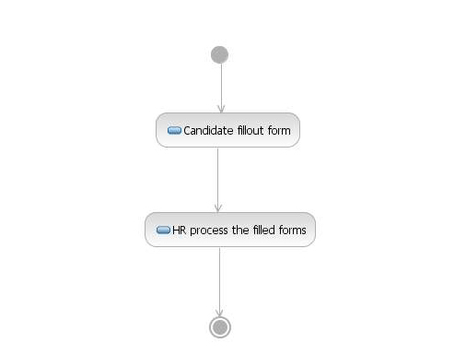
- Interview Process
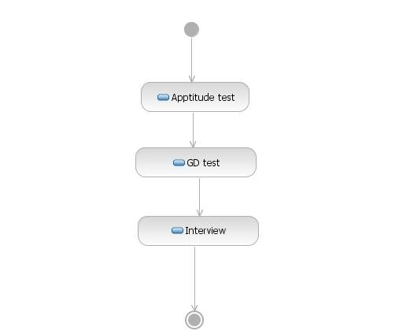
- Status
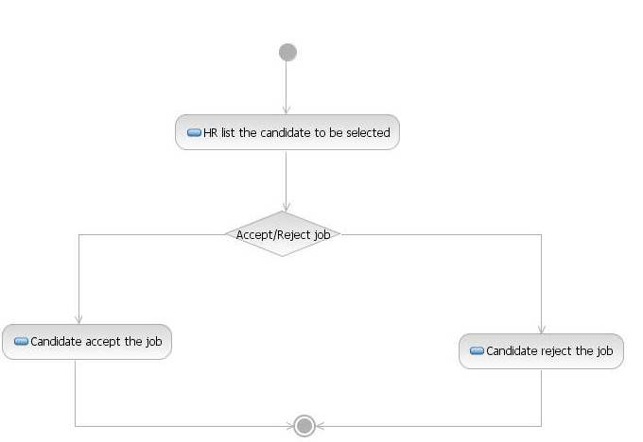

SEQUENCE DIAGRAM

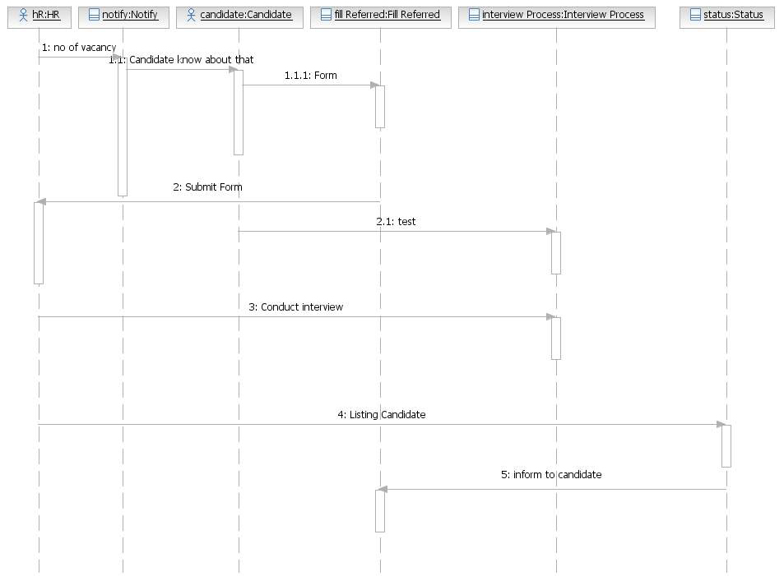

Class Diagram

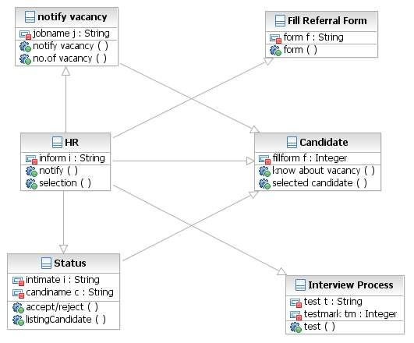

Communication Diagram

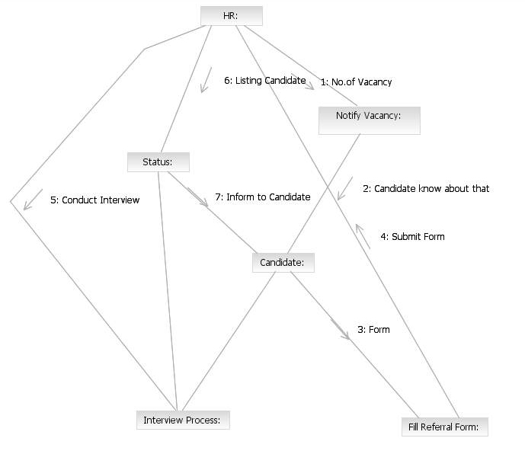
Forward Engineering Code
Code Generation for HR
Package Package2;
/** *@author user1 * @generated “UML to Java V5.0 (com.ibm.xtools.transform.uml2.java5.internal.UML2JavaTransform)” */
Public class HR {
/** *@generated “UML to Java V5.0

(com.ibm.xtools.transform.uml2.java5.internal.UML2JavaTransform)” */
Private notify-vacancy notify-vacancy;
/** *@generated “UML to Java V5.0

(com.ibm.xtools.transform.uml2.java5.internal.UML2JavaTransform)” */
Private Candidate candidate;
/** *@generated “UML to Java V5.0

(com.ibm.xtools.transform.uml2.java5.internal.UML2JavaTransform)” */
Private Status status;
/** *@generated “UML to Java V5.0

(com.ibm.xtools.transform.uml2.java5.internal.UML2JavaTransform)” */
Private Interview-process interview-process;
/** *@generated “UML to Java V5.0

(com.ibm.xtools.transform.uml2.java5.internal.UML2JavaTransform)” */
Private String inform1i;
/** *@generated “UML to Java V5.0

(com.ibm.xtools.transform.uml2.java5.internal.UML2JavaTransform)” */
Public void notify() {
//begin-user-code & TODO Auto-generated method stub & end-user-code
}

/** *@generated “UML to Java V5.0

(com.ibm.xtools.transform.uml2.java5.internal.UML2JavaTransform)” */
Public void selection() {
//begin-user-code & TODO Auto-generated method stub & end-user-code
}
}

Code Generation for Notify Vacancy
Package Package2;
/** *@author user1 * @generated “UML to Java V5.0
(com.ibm.xtools.transform.uml2.java5.internal.UML2JavaTransform)” */
Private notify-vacancy {
/** *@generated “UML to Java V5.0

(com.ibm.xtools.transform.uml2.java5.internal.UML2JavaTransform)” */
Private Candidate candidate;
/** *@generated “UML to Java V5.0

(com.ibm.xtools.transform.uml2.java5.internal.UML2JavaTransform)” */
Private String jobnamej;
/** *@generated “UML to Java V5.0

(com.ibm.xtools.transform.uml2.java5.internal.UML2JavaTransform)” */
Public void notify-vacancy() {
//begin-user-code & TODO Auto-generated method stub & end-user-code
}

/** *@generated “UML to Java V5.0

(com.ibm.xtools.transform.uml2.java5.internal.UML2JavaTransform)” */
Public void noofvacancy() {
//begin-user-code & TODO Auto-generated method stub & end-user-code
}
}

Code Generation for Candidate

Package Package2;
/** *@author user1 * @generated “UML to Java V5.0 (com.ibm.xtools.transform.uml2.java5.internal.UML2JavaTransform)” */
Public class Candidate extends FillReferralForm {
/** *@generated “UML to Java V5.0

(com.ibm.xtools.transform.uml2.java5.internal.UML2JavaTransform)” */
Private FillReferralForm fillreferralform;
/** *@generated “UML to Java V5.0

(com.ibm.xtools.transform.uml2.java5.internal.UML2JavaTransform)” */
Private Interview-process interview-process;
/** *@generated “UML to Java V5.0

(com.ibm.xtools.transform.uml2.java5.internal.UML2JavaTransform)” */
Private String fillform f;
/** *@generated “UML to Java V5.0

(com.ibm.xtools.transform.uml2.java5.internal.UML2JavaTransform)” */
Public void knowaboutvacancy() {
//begin-user-code & TODO Auto-generated method stub & end-user-code
}

/** *@generated “UML to Java V5.0

(com.ibm.xtools.transform.uml2.java5.internal.UML2JavaTransform)” */
Public void selected-candidates() {
//begin-user-code & TODO Auto-generated method stub & end-user-code
}
}

Code Generation for Fill Referral Form
Package Package2;
/** *@author user1 * @generated “UML to Java V5.0
(com.ibm.xtools.transform.uml2.java5.internal.UML2JavaTransform)” */
Public class FillReferralForm {
/** *@generated “UML to Java V5.0

(com.ibm.xtools.transform.uml2.java5.internal.UML2JavaTransform)” */
Private HR hr;
/** *@generated “UML to Java V5.0

(com.ibm.xtools.transform.uml2.java5.internal.UML2JavaTransform)” */
Private String form1 f;
/** *@generated “UML to Java V5.0

(com.ibm.xtools.transform.uml2.java5.internal.UML2JavaTransform)” */
Public void form () {
//begin-user-code & TODO Auto-generated method stub & end-user-code
}

}

Code Generation for Interview Process
Package Package2;
/** *@author user1 * @generated “UML to Java V5.0 (com.ibm.xtools.transform.uml2.java5.internal.UML2JavaTransform)” */
Public class Interview-process{
/** *@generated “UML to Java V5.0

(com.ibm.xtools.transform.uml2.java5.internal.UML2JavaTransform)” */
Private String test1 t;
/** *@generated “UML to Java V5.0

(com.ibm.xtools.transform.uml2.java5.internal.UML2JavaTransform)” */
Private Integer test1 marktm;
/** *@generated “UML to Java V5.0

(com.ibm.xtools.transform.uml2.java5.internal.UML2JavaTransform)” */
Public void test() {
//begin-user-code & TODO Auto-generated method stub & end-user-code
}

/** *@generated “UML to Java V5.0

(com.ibm.xtools.transform.uml2.java5.internal.UML2JavaTransform)” */
Public void informtocandidate() {
//begin-user-code & TODO Auto-generated method stub & end-user-code
}

/** *@generated “UML to Java V5.0

(com.ibm.xtools.transform.uml2.java5.internal.UML2JavaTransform)” */
Public void conduct interview() {
//begin-user-code & TODO Auto-generated method stub & end-user-code
}
}
Code Generation for Status

Package Package2;
/** *@author user1 * @generated “UML to Java V5.0 (com.ibm.xtools.transform.uml2.java5.internal.UML2JavaTransform)” */
Public class Status {
/** *@generated “UML to Java V5.0

(com.ibm.xtools.transform.uml2.java5.internal.UML2JavaTransform)” */
Private Candidate candidate;
/** *@generated “UML to Java V5.0

(com.ibm.xtools.transform.uml2.java5.internal.UML2JavaTransform)” */
Private String intimate i;
/** *@generated “UML to Java V5.0

(com.ibm.xtools.transform.uml2.java5.internal.UML2JavaTransform)” */
Private String Candname cnc;
/** *@generated “UML to Java V5.0

(com.ibm.xtools.transform.uml2.java5.internal.UML2JavaTransform)” */
Public void accept-reject () {
//begin-user-code & TODO Auto-generated method stub & end-user-code
}

/** *@generated “UML to Java V5.0

(com.ibm.xtools.transform.uml2.java5.internal.UML2JavaTransform)” */
Public void listingcandi() {
//begin-user-code & TODO Auto-generated method stub & end-user-code
}
}

